Marathwada Shikshan Prasarak Mandal’s

DEOGIRI COLLEGE (AUTONOMOUS)
Chhatrapati Sambhajinagar-431005, Maharashtra, India

Department of Master of Computer Application (MCA)

Major Project

Report

On

“Campus Placement Data Analysis using EDA”

Submitted By
Sargam Tryambak Khillare (2025/MCA/71)
Class & Semester: MCA F.Y II Sem
Academic Year: 2025-26

Guided By

Mrs. Rewati P. Arole

Submitted to
DEPARTMENT OF MASTER OF COMPUTER APPLICATION(MCA)

Marathwada Shikshan Prasarak Mandal’s

DEOGIRI COLLEGE (AUTONOMOUS)
Chhatrapati Sambhajinagar-431005, Maharashtra, India

Department of Master of Computer Application (MCA)

CERTIFICATE

This is to certify that Mr/ Ms. Sargam Tryambak Khillare, Roll No. 71 Student of MCA F.Y Semester-II has successfully completed the Major Project work on Title “ Campus Placement Data Analysis Using EDA” under my guidance. This report submitted to Department of Master of Computer Application, Deogiri College, Chhatrapati Sambhajinagar in the AY 2025-26 for partial fulfillment and requirement for the End Semester Examination.

Project Guide H.O.D

External Examiner Principal

Place: Deogiri College, Chhatrapati Sambhajinagar
Date: 30-03-2026

DECLARATION

I/We hereby declare that the Project work titled “Campus Placement Data Analysis using EDA” submitted to Deogiri College, Chhatrapati Sambhajinagar is a record of an original work done by me under the guidance of Mrs. Rewati P. Arole Department of Master of Computer Application, Deogiri College, Chhatrapati Sambhajinagar in the AY 2025-26 for a partial fulfillment of requirement for the Completion of End Semester Examination.
This report has not been submitted to any other University, College or Institute for the award of any degree or diploma.

Student Name: Sargam Tryambak Khillare(2025/MCA/071)

Date:

Place: Chhatrapati Sambhajinagar.

ACKNOWLEDGEMENT
I would like to express my special thanks of gratitude’s to our Project Mrs. Rewati P. Arole Department of Master of Computer Application, Deogiri College, Chhatrapati Sambhajinagar for her valuable guidance and support in completing this report.
I/We would like to extend my gratitude to Dr. Ravi Patil, Principal, Deogiri College, Dr. Vivek Mahale, HOD, MCA for providing me/us with all the facility that was required to complete this report successfully.
I/We also thank the management of Deogiri College, Chhatrapati Sambhajinagar for providing me/us infrastructure and lab facility to completion of this Project.
At last but not the least I/we am/are thankful to all faculty members, staff, and friends who have been always helping and encouraging me/us throughout the period of this internship/project.

Student Name: : Sargam Tryambak Khillare(2025/MCA/071)

ABSTRACT
This project focuses on performing Exploratory Data Analysis (EDA) on a campus placement dataset to understand the key factors influencing student placement and salary outcomes. The dataset contains information about students’ academic performance, technical and soft skills, internships, projects, work experience, and placement status.
The primary objective of this study is to analyze the relationship between various attributes such as academic scores, skill levels, backlogs, and practical exposure with placement success and salary packages. The analysis begins with data preprocessing steps, including handling missing values and removing outliers using statistical techniques to ensure data quality and accuracy.
Various visualization techniques such as count plots, box plots, scatter plots, histograms, and heatmaps were used to explore patterns and relationships among variables. Univariate, bivariate, and multivariate analyses were performed to gain deeper insights into the dataset. The results indicate that technical skills, aptitude, communication skills, and practical experience (internships and projects) have a strong positive impact on placement outcomes.
Additionally, the study highlights that students with fewer academic backlogs are more likely to secure placements, while higher practical exposure leads to better salary packages. Although academic performance contributes to placement decisions, it is not the sole determining factor, as skill-based competencies play a more significant role in employability.
In conclusion, this project demonstrates that a balanced combination of academic achievement, skill development, and real-world experience is essential for successful campus placements. The findings of this analysis can help students focus on improving relevant skills and assist educational institutions in enhancing their training programs to increase placement success rates.
TABLE OF CONTENT

Chapter | Chapter Name | Page No
1 | Introduction
 | 1.1 Introduction
 | 1.2 Overview of Exploratory Data Analysis
 | 1.3 Importance of EDA
 | 1.4 Project Motivation
2 | Literature Review
 | 2.1 Related Work
 | 2.2 Existing Systems
 | 2.3 Limitations of Existing Systems
3 | Problem Definition
 | 3.1 Problem Statement
 | 3.2 Objectives of the Project
 | 3.3 Scope of the Project
4 | System Requirement
 | 4.1 Hardware Requirements
 | 4.2 Software Requirements
5 | Dataset Description
 | 5.1 Data Source
 | 5.2 Description of Attributes
 | 5.3 Dataset Structure
6 | Methodology
 | 6.1 Data Collection
 | 6.2 Data Preprocessing
 | 6.3 Data Cleaning
 | 6.4 Data Transformation

Chapter | Chapter Name | Page No
 | 6.5 Exploratory Data Analysis Techniques
7 | Data Visualization
 | 7.1 Univariate Analysis
 | 7.2 Bivariate Analysis
 | 7.3 Multivariate Analysis
 | 7.4 Graphical Representation
8 | Results and Discussion
 | 8.1 Statistical Summary
 | 8.2 Observations
 | 8.3 Key Insights
9 | Project Implementation
 | 9.1 Sample Code
 | 9.2 Output Screenshots
10 | Conclusion
 | 10.1 Conclusion
 | 10.2 Future Enhancements
11 | References

CHAPTER 1

Introduction

  - Introduction
Exploratory Data Analysis (EDA) is one of the most important steps in data analysis. It helps in understanding the dataset before applying any advanced techniques. In simple words, EDA means exploring the data to find useful information, patterns, and relationships between different variables. In this project, EDA is performed on a campus placement dataset to analyze the factors that influence student placement and salary.
The dataset used in this project contains information about students such as age, gender, academic performance, technical skills, soft skills, aptitude, backlogs, and placement status. By analyzing this data, we can understand what helps students get placed and what factors reduce their chances.
The main goal of this project is to study the relationship between different variables and placement outcomes. For example, we analyze whether students with higher technical skills have better placement chances or how backlogs affect salary. This type of analysis helps in making better decisions.
EDA involves multiple steps such as data cleaning, data visualization, and statistical analysis. Data cleaning ensures that the dataset is free from errors and missing values. Visualization helps in understanding the data easily using graphs and charts.
In this project, different types of graphs like histograms, boxplots, scatter plots, and heatmaps are used. These graphs make it easier to understand patterns in the data. For example, we can visually see how salary varies with skills or how placement depends on different factors.
Another important part of this project is outlier detection. Outliers are unusual values that can affect the results. Removing these values improves the accuracy of the analysis.
Overall, this project helps in understanding the placement process and identifying the most important factors that influence it.

  - Overview of Exploratory Data Analysis
Exploratory Data Analysis (EDA) is a process used to analyze and summarize datasets. It is usually the first step in any data science project. The main purpose of EDA is to understand the structure of the data and identify important patterns.
EDA includes several steps such as data collection, data cleaning, data transformation, and data visualization. Each step plays an important role in making the data ready for analysis.
1
In this project, EDA is used to explore the campus placement dataset. The dataset is first loaded into the system using Python. Then, different functions are used to understand the dataset, such as checking the number of rows and columns, column names, and data types.
Data cleaning is an important part of EDA. It involves handling missing values and removing duplicate records. If the data is not clean, the results of the analysis may not be accurate.
Visualization is another key part of EDA. It helps in representing data in graphical form. Graphs like histograms, scatter plots, and heatmaps make it easier to understand trends and relationships. For example, a scatter plot can show how two variables are related, while a heatmap shows correlation between multiple variables.
EDA also helps in identifying outliers. Outliers are extreme values that do not follow the normal pattern of data. These values can affect the analysis and should be handled properly.
Overall, EDA provides a clear understanding of the dataset and helps in making better decisions.

  - Importance of EDA
EDA is very important in any data analysis project because it helps in understanding the data in a better way. Without EDA, it is difficult to analyze data correctly.
One of the main advantages of EDA is that it helps in identifying errors in the dataset. These errors can be missing values, duplicate records, or incorrect data. By fixing these errors, we can improve the quality of the data.
EDA also helps in understanding the distribution of data. For example, we can see whether the data is evenly distributed or not. This helps in choosing the right analysis methods.
Another important benefit of EDA is that it helps in identifying relationships between variables. For example, we can analyze how technical skills affect placement or how backlogs impact salary.
Visualization is a key part of EDA. Graphs and charts make it easier to understand complex data. Instead of looking at numbers, we can see patterns visually.
EDA also helps in detecting outliers. Outliers can affect the results of analysis, so it is important to identify and handle them properly.
In this project, EDA helps in understanding the factors affecting placement and salary. It provides useful insights that can help students improve their skills and increase their chances of getting placed.

2
  - Project Motivation
The primary motivation behind this project is to understand the factors that significantly influence student

placement and salary outcomes. In today’s competitive environment, students often focus heavily on academic performance, assuming that high grades alone will guarantee placement. However, real-world hiring practices indicate that employers consider a broader set of criteria, including skills, experience, and personality traits.
This project aims to bridge the gap between student expectations and industry requirements by analyzing real placement data. By identifying the key factors that contribute to successful placements, students can focus on developing the right skills and gaining relevant experience.
Another motivation for this project is to assist educational institutions in improving their placement strategies. By understanding which factors have the greatest impact on placement outcomes, institutions can design better training programs, workshops, and internship opportunities for students.
Additionally, this project provides practical exposure to data analysis techniques, which are highly valuable in today’s data-driven world. Learning how to work with real datasets, perform data cleaning, and generate insights through visualization enhances analytical and problem-solving skills.
The project also serves as a foundation for future work in data science and machine learning. The insights gained from EDA can be used to build predictive models that can forecast placement outcomes based on student profiles.
In conclusion, the motivation for this project lies in improving student employability, enhancing institutional effectiveness, and gaining practical knowledge of data analysis techniques.

3

CHAPTER 2
Literature Review

2.1 Related Work
Many researchers and data analysts have worked on student placement analysis using data science techniques. In earlier studies, placement prediction was mainly based on academic performance such as marks obtained in school and college. However, recent research shows that placement depends on multiple factors, including technical skills, soft skills, and practical experience.
Several studies have used data analysis and machine learning techniques to predict whether a student will be placed or not. These studies highlight that students with strong technical knowledge and good communication skills have a higher chance of getting placed. Some research also shows that participation in internships and projects plays an important role in improving placement chances.
In addition, researchers have used different visualization techniques to understand the data better. Graphs like scatter plots, bar charts, and heatmaps are commonly used to identify patterns and relationships between variables. For example, a scatter plot can show the relationship between skills and salary, while a heatmap can show correlation between multiple variables.
Some studies also focus on identifying outliers in the dataset. Outliers are unusual values that can affect the analysis. Removing these values helps in improving the accuracy of results. Techniques like the IQR method and boxplots are commonly used for this purpose.
Datasets for such studies are often collected from platforms like Kaggle, which provides real-world data for analysis. These datasets help researchers understand actual placement scenarios.
Overall, previous research shows that placement is not dependent on a single factor but is influenced by a combination of academic performance, skills, and experience.

2.2 Existing Systems
Existing systems for placement analysis mainly focus on basic evaluation of students. Most traditional systems consider only academic marks such as school percentage, college percentage, and grades. These systems do not analyze other important factors like technical skills, communication skills, and practical experience.

4

In many colleges, placement decisions are made based on simple criteria such as minimum marks or eligibility conditions. These systems do not use advanced data analysis techniques to understand the complete profile of a student. As a result, they may not provide accurate insights into placement outcomes.

Some existing systems use basic statistical methods to analyze placement data. However, they do not include proper visualization techniques. Without visualization, it becomes difficult to understand patterns and relationships in the data.
Another limitation of existing systems is that they do not handle data properly. Missing values, duplicate records, and outliers are often ignored. This reduces the quality of analysis and may lead to incorrect conclusions.
In recent years, some systems have started using machine learning models for placement prediction. These models can provide better accuracy, but they require proper data preprocessing and analysis. Without EDA, even machine learning models may not perform well.
Compared to these systems, this project uses a complete EDA approach. It includes data cleaning, visualization, and outlier detection. This helps in understanding the dataset more clearly and provides better insights.

2.3 Limitations of Existing Systems
Existing systems for placement analysis have several limitations that reduce their effectiveness. One major limitation is that they focus only on academic performance. In today’s job market, companies look for more than just marks. Skills, communication ability, and practical knowledge are equally important.
Another limitation is the lack of proper data analysis. Many systems do not use advanced techniques like EDA. Without EDA, it is difficult to understand the dataset and identify patterns. This can lead to incomplete or incorrect results.
Data quality is another major issue in existing systems. Missing values, duplicate records, and incorrect data are not handled properly. This affects the accuracy of analysis. For example, if missing values are not handled, the results may be biased.
Visualization is also missing in many systems. Without graphs and charts, it is difficult to understand complex data. Visualization helps in presenting data in a simple and clear way.
Outlier detection is another area where existing systems lack. Outliers can affect the results significantly. If they are not removed, the analysis may not be accurate.

5

Another limitation is that many systems do not consider multiple variables together. They analyze each factor separately, which does not give a complete picture. Multivariate analysis is important to understand how different factors work together.
This project overcomes these limitations by using proper EDA techniques. It includes data cleaning, visualization, and outlier detection, which improves the quality of analysis and provides better insights.

6

CHAPTER 3
Problem Definition

3.1 Problem Statement
The main problem addressed in this project is to analyze student data and identify the factors that influence placement and salary outcomes. Many students are unsure about what factors are important for getting placed. Some focus only on academics, while others focus only on skills. This creates confusion.
The dataset contains multiple variables such as academic performance, technical skills, soft skills, aptitude, and backlogs. The challenge is to analyze these variables and understand their impact on placement.
Another problem is that raw data may contain errors such as missing values, duplicates, and outliers. These issues need to be handled before analysis. If not handled properly, they can affect the results.
The project also aims to identify relationships between variables. For example, how technical skills affect salary or how backlogs affect placement. Understanding these relationships is important for making better decisions.
In addition, the project aims to present the results in a clear and simple way using visualization techniques. This helps in understanding the data easily.
Overall, the problem is to perform a complete analysis of the dataset and extract meaningful insights.

3.2 Objectives of the Project
The main objective of this project is to perform Exploratory Data Analysis on the campus placement dataset and identify the key factors affecting placement and salary.
The specific objectives are:
- To understand the dataset structure and attributes
- To clean the data by handling missing values and duplicates
- To perform univariate analysis to study individual variables
- To perform bivariate analysis to study relationships between two variables
- To perform multivariate analysis to study multiple variables together

7

- To detect and remove outliers using IQR method
- To visualize data using graphs and charts
- To calculate placement rate

Another objective is to make the analysis simple and easy to understand. The use of visualization helps in

achieving this goal.
The project also aims to provide useful insights that can help students improve their placement chances.

8

CHAPTER 4
System Requirements

4.1 Hardware Requirements
Hardware requirements refer to the physical components needed to run the project smoothly. Since this project is based on Exploratory Data Analysis (EDA) using Python, it does not require very high-end hardware. However, a basic system with good performance is necessary for smooth execution.
The minimum hardware requirements include a computer or laptop with at least 4 GB RAM. This is enough to run Python programs and perform basic data analysis. However, for better performance, especially when working with larger datasets, 8 GB RAM is recommended. More RAM helps in faster data processing and prevents system lag.
The processor is another important component. A system with an Intel i3 or equivalent processor can run the project, but an Intel i5 or higher is recommended for better speed and performance. A good processor ensures that calculations and visualizations are generated quickly.
Storage is also important. At least 10 GB of free disk space is required to store the dataset, Python libraries, and project files. Solid State Drives (SSD) are preferred over Hard Disk Drives (HDD) because they provide faster read and write speeds.
A stable internet connection is also required, especially when working on platforms like Google Colab. Internet is needed to upload datasets, install libraries, and access resources. The dataset used in this project is downloaded from Kaggle, so internet access is necessary.
In addition, a display screen with good resolution helps in viewing graphs and charts clearly. Since data visualization is an important part of this project, clear visibility of graphs is necessary.
Overall, the hardware requirements for this project are simple and affordable. Even a basic laptop can handle the project efficiently.

4.2 Software Requirements
Software requirements include the tools and applications needed to develop and run the project. This project mainly uses Python and its libraries for data analysis and visualization.
The primary software used is Python programming language. Python is widely used in data science because it is easy to learn and has many powerful libraries. It allows users to perform data analysis efficiently.
9

The project is executed using Google Colab, which is a cloud-based platform. It does not require installation and can be accessed through a web browser. Google Colab provides free access to computing resources and supports Python programming.
Several Python libraries are used in this project. These include:
- Pandas: Used for data handling and manipulation
- NumPy: Used for numerical operations
- Matplotlib: Used for basic data visualization
- Seaborn: Used for advanced and attractive graphs
These libraries help in performing different tasks such as loading data, cleaning data, analyzing data, and creating visualizations.
The dataset is loaded using CSV format, which is supported by Pandas. The read_csv() function is used to load the dataset into the program.
Another important software requirement is a web browser such as Chrome or Edge. This is needed to access Google Colab and upload files.
The project also requires basic knowledge of Python programming and data analysis concepts. Understanding how to use libraries and functions is important for successful execution.
Overall, the software requirements are simple and easily available. Most of the tools used are free and open-source, making the project accessible to everyone.

10

CHAPTER 5
Dataset Description

5.1 Data Source
The dataset used in this project is taken from Kaggle, which is a popular online platform for data science and machine learning. Kaggle provides a large collection of datasets that can be used for practice and research.
The campus placement dataset contains information about students and their placement outcomes. It includes various attributes such as academic performance, skills, and placement status. This dataset is suitable for performing Exploratory Data Analysis because it contains both numerical and categorical data.
The data is available in CSV format, which is easy to use with Python. It can be uploaded directly into Google Colab and loaded using Pandas.
Using real-world datasets like this helps in understanding actual placement scenarios. It provides practical experience in handling and analyzing data.

5.2 Description of Attributes
The dataset contains several attributes that describe different aspects of students. Each attribute provides useful information for analysis.
Some of the important attributes include:
- Age: Represents the age of the student
- Gender: Indicates whether the student is male or female
- Degree Percentage: Shows academic performance in graduation
- Specialization: Indicates the field of study
- Technical Skills Score: Measures technical knowledge
- Soft Skills Score: Measures communication and interpersonal skills
- Aptitude Score: Represents logical and problem-solving ability
- Backlogs: Number of subjects not cleared
- Salary (LPA): Salary offered to the student
- Placed: Indicates whether the student is placed (1) or not (0)
11

Each attribute plays an important role in analysis. For example, technical skills may have a strong impact on placement, while backlogs may reduce chances.
Understanding these attributes helps in performing better analysis and extracting meaningful insights.
5.3 Dataset Structure
The dataset is structured in tabular format, where rows represent individual students and columns represent attributes.
Each row contains complete information about a student. For example, one row may include age, gender, skills, and placement status of a student.
The dataset contains both numerical and categorical data. Numerical data includes values like age, salary, and scores. Categorical data includes values like gender and specialization.
The dataset may also contain missing values and duplicate records. These need to be handled during data cleaning.
The structure of the dataset is analyzed using functions like:
- df.shape to find number of rows and columns
- df.columns to view column names
- df.info() to check data types
- df.describe() to get statistical summary
Understanding the dataset structure is important before performing analy

12

CHAPTER 6
Methodology

6.1 Data Collection
Data collection is the first and most important step in any data analysis project. In this project, the dataset is collected from Kaggle, which is a well-known platform for data science, machine learning, and analytics. Kaggle provides a wide variety of real-world datasets that help students and researchers perform practical analysis.
The dataset used in this project is related to campus placement. It contains detailed information about students such as their academic performance, technical skills, soft skills, aptitude scores, number of backlogs, and placement status. This data helps in understanding the placement process and identifying the key factors that influence it.
The dataset is available in CSV (Comma Separated Values) format, which is easy to use with Python. After downloading the dataset from Kaggle, it is uploaded into Google Colab using the files.upload() function. Google Colab is a cloud-based platform that allows users to write and execute Python code without installing any software.
Once the dataset is uploaded, it is loaded into the program using the Pandas library. The read_csv() function is used to read the dataset and store it in a DataFrame. A DataFrame is a table-like structure that makes it easy to work with data.
After loading the dataset, the first few rows are displayed using the head() function. This helps in getting an initial idea about the data. The shape of the dataset is also checked using df.shape to understand the number of rows and columns.
Data collection is not just about downloading the dataset. It also involves ensuring that the dataset is suitable for analysis. The dataset chosen for this project is relevant because it contains multiple attributes that affect placement.
Overall, the data collection step ensures that the project starts with reliable and meaningful data. Without proper data collection, the entire analysis may not be accurate.

6.2 Data Preprocessing
Data preprocessing is the process of preparing the data for analysis. Raw data is often not in a perfect format, so it needs to be processed before performing any analysis. This step helps in understanding the structure of the dataset and making it ready for further steps.
13
In this project, data preprocessing starts by exploring the dataset using different Pandas functions. The df.head() function is used to display the first five rows of the dataset. This gives a quick overview of the data.
Next, the structure of the dataset is analyzed using df.shape, which shows the number of rows and columns. This helps in understanding the size of the dataset.
The column names are checked using df.columns. This is important because it helps in identifying different attributes present in the dataset.
The df.info() function is used to get detailed information about the dataset. It shows data types of each column and also indicates if there are any missing values. Data types are important because they determine how the data will be processed.
Statistical summary is obtained using df.describe(). This function provides important information such as mean, median, minimum, maximum, and standard deviation for numerical columns. This helps in understanding the distribution of data.
Preprocessing also includes checking for missing values using df.isnull().sum(). Missing values can affect the analysis, so they need to be handled properly.
Another important step is checking for duplicate records using df.duplicated().sum(). Duplicate data can lead to incorrect results, so it is important to identify and remove them.
Overall, data preprocessing ensures that the dataset is well understood and ready for cleaning and analysis. It provides a clear picture of the data and helps in identifying issues that need to be fixed.

6.3 data cleaning
Data cleaning is one of the most important steps in data analysis. It involves fixing errors and improving the quality of the dataset. If the data is not clean, the results of the analysis may not be accurate.
In this project, data cleaning involves handling missing values and removing duplicate records. Missing values are common in real-world datasets. They occur when some information is not available.
In the given dataset, missing values are present in the specialization column. These missing values are replaced with “Not Available” using the fillna() function. This ensures that the dataset does not contain any empty values.
Duplicate records are also checked using df.duplicated().sum(). If duplicates are found, they are removed using df.drop_duplicates(). Removing duplicates is important because they can distort the analysis.
Another important part of data cleaning is checking for incorrect or inconsistent data. For example, if a column contains unexpected values, it needs to be corrected.
14

Data cleaning also improves the readability of the dataset. Clean data is easier to understand and analyze.
Proper data cleaning ensures that the dataset is reliable and accurate. It helps in avoiding errors and
improves the quality of analysis.

6.4 Data Transformation
In this project, data transformation includes handling Data transformation is the process of converting data into a suitable format for analysis. It involves modifying the data so that it can be easily used for visualization and analysis.
categorical and numerical data. Categorical data such as gender and specialization are used for grouping and comparison. Numerical data such as scores and salary are used for calculations and visualization.
The dataset is structured in a way that makes it easy to perform analysis. Columns are properly labeled, and data types are correctly assigned.
Transformation also includes preparing the data for visualization. For example, numerical columns are used to create histograms and scatter plots, while categorical columns are used to create count plots.
Another important part of transformation is ensuring consistency in the data. All values should be in the correct format. For example, numerical values should not contain text.
Data transformation helps in making the dataset more useful and easier to analyze. It ensures that the data is in the right format for performing EDA techniques.

6.5 Exploratory Data Analysis Techniques
Exploratory Data Analysis (EDA) techniques are used to analyze and understand the dataset. In this project, three main types of analysis are performed: univariate analysis, bivariate analysis, and multivariate analysis.
Univariate analysis focuses on a single variable. For example, a histogram is used to analyze the distribution of age. A boxplot is used to identify outliers in salary. Count plots are used to analyze categorical variables like placement status.
Bivariate analysis focuses on the relationship between two variables. For example, a scatter plot is used to analyze the relationship between degree percentage and salary. Another example is analyzing gender and placement using count plots.

15

Multivariate analysis involves analyzing multiple variables together. A heatmap is used to show correlation between different numerical variables. This helps in understanding how variables are related to each other.
Visualization plays a key role in EDA. Graphs and charts make it easier to understand complex data. Instead of looking at numbers, patterns can be seen visually.

Outlier detection is also an important part of EDA. In this project, the IQR (Interquartile Range) method is used to identify and remove outliers. Outliers are extreme values that can affect the analysis.
By using these techniques, the dataset is explored in detail. This helps in identifying patterns, trends, and relationships between variables

16

CHAPTER 7
Data Visualization

7.1 Univariate Analysis
Univariate analysis is the process of analyzing a single variable at a time. It helps in understanding the basic features and distribution of data. In this project, univariate analysis is used to study individual attributes such as age, salary, and placement status.
One of the main graphs used in univariate analysis is the histogram. A histogram is used to show the distribution of numerical data. In this project, a histogram is created for the age column. This graph shows how students are distributed across different age groups. It helps in understanding whether most students belong to a particular age group or if the data is spread evenly.
Another important visualization used is the boxplot. A boxplot is used to identify the spread of data and detect outliers. In this project, a boxplot is created for the salary column. This helps in understanding the range of salaries offered to students. It also highlights any extreme values that do not follow the normal pattern.
Count plots are used to analyze categorical variables. In this project, a count plot is created for the placement status. The placement status is represented as 1 for placed and 0 for not placed. This graph shows the number of students who got placed and those who did not. It provides a clear idea about the overall placement scenario.
Univariate analysis is important because it helps in understanding each variable individually. It also helps in identifying issues such as skewness and outliers. By analyzing each variable separately, we can get a better understanding of the dataset.
Overall, univariate analysis provides a strong foundation for further analysis. It helps in understanding the basic characteristics of the data and prepares it for deeper analysis.

7.2 Bivariate Analysis
Bivariate analysis is used to study the relationship between two variables. It helps in understanding how one variable affects another. In this project, bivariate analysis is performed using different types of graphs such as scatter plots and count plots.
One of the important graphs used in bivariate analysis is the scatter plot. A scatter plot is used to show the relationship between two numerical variables. In this project, a scatter plot is created between backlogs

17
and salary. This graph helps in understanding how the number of backlogs affects the salary of students. It is observed that students with more backlogs tend to have lower salaries.
Another important analysis is performed using count plots. A count plot is used to analyze the relationship between categorical variables. In this project, a count plot is created between gender and placement status. This graph shows how placement varies between male and female students.
Boxplots are also used in bivariate analysis. For example, a boxplot is created between placement status and technical skills score. This graph helps in understanding how technical skills influence placement. It is observed that students with higher technical skills have a better chance of getting placed.
Bivariate analysis helps in identifying patterns and relationships between variables. It provides deeper insights compared to univariate analysis. By studying two variables together, we can understand how they interact with each other.
Overall, bivariate analysis plays an important role in understanding the factors that affect placement and salary.

7.3 Multivariate Analysis
Multivariate analysis involves analyzing more than two variables at the same time. It helps in understanding complex relationships between multiple factors. In this project, multivariate analysis is performed using scatter plots and heatmaps.
One of the key visualizations used is a scatter plot with three variables. In this graph, technical skills score is plotted on the x-axis, salary on the y-axis, and placement status is shown using different colors. This type of graph helps in understanding how multiple variables are related.
For example, this graph shows that students with higher technical skills generally have higher salaries and are more likely to be placed. It also shows how placement status varies with skills and salary.
Another important visualization used in multivariate analysis is the heatmap. A heatmap is used to show the correlation between multiple numerical variables. Correlation indicates how strongly two variables are related.
In this project, a heatmap is created using the correlation matrix. It shows the relationship between variables such as technical skills, soft skills, aptitude, salary, and backlogs. Positive correlation means that both variables increase together, while negative correlation means that one increases while the other decreases.
18

Multivariate analysis provides a deeper understanding of the dataset. It helps in identifying the most important factors that affect placement.
Overall, multivariate analysis is useful for making better decisions and understanding complex data relationships.

7.4 Graphical Representation
Graphical representation is an important part of data visualization. It helps in presenting data in a visual form, making it easier to understand. Instead of looking at large tables of numbers, graphs provide a clear and simple way to see patterns and trends.
In this project, different types of graphs are used for visualization. These include histograms, boxplots, scatter plots, count plots, and heatmaps. Each type of graph serves a different purpose.
Histograms are used to show the distribution of numerical data. They help in understanding how data is spread across different values.
Boxplots are used to show the spread of data and identify outliers. They provide information about the minimum, maximum, median, and quartiles.
Scatter plots are used to show relationships between two numerical variables. They help in identifying trends and patterns.
Count plots are used for categorical data. They show the frequency of each category.
Heatmaps are used to show correlation between multiple variables. They provide a visual representation of relationships in the dataset.
Graphical representation makes it easier to communicate results. It helps in presenting findings in a clear and understandable way. This is especially useful for decision-making.
Overall, graphical representation is an essential part of this project. It helps in understanding the data and extracting meaningful insights.

19

CHAPTER 8
Results & Discussion

8.1 Statistical Summary
Statistical summary is an important step in data analysis. It helps in understanding the basic properties of the dataset using numerical values. In this project, statistical summary is obtained using the describe() function of the Pandas library.
The statistical summary includes measures such as mean, median, minimum, maximum, and standard deviation. These values help in understanding the distribution of data.
The mean represents the average value of a column. For example, the average salary gives an idea about the general salary offered to students. The median represents the middle value, which is useful when the data contains outliers.
The minimum and maximum values show the range of the data. For example, the minimum and maximum salary indicate the lowest and highest salary offered. The standard deviation shows how much the data varies from the mean.
From the statistical summary, it is observed that there is variation in student performance and salary. Some students have high technical and aptitude scores, while others have lower scores. This variation affects placement outcomes.
The summary also helps in identifying outliers. If the maximum value is much higher than the average, it may indicate the presence of outliers.
Another important observation is that students with higher scores in technical and aptitude tests tend to have better placement outcomes. This shows that skills play an important role in placement.
Overall, the statistical summary provides a clear overview of the dataset. It helps in understanding the distribution and variation of data, which is useful for further analysis.

8.2 Observations
Observations are the key findings obtained from the analysis of the dataset. In this project, several important observations are made using different visualization techniques.

20
One of the main observations is related to placement status. The count plot shows that a significant number of students are placed, while some are not. This indicates that placement depends on multiple factors.
Another observation is related to technical skills. The boxplot shows that students with higher technical skills scores have a higher chance of getting placed. This highlights the importance of technical knowledge in the placement process.
Backlogs also have a negative impact on placement. The scatter plot shows that students with more backlogs tend to have lower salaries and fewer placement opportunities. This suggests that clearing backlogs is important for better career opportunities.
Gender-based analysis shows that placement opportunities are distributed across both male and female students. However, the exact distribution may vary depending on other factors such as skills and performance.
The heatmap provides insights into the correlation between variables. It shows that salary is positively correlated with technical skills and aptitude scores. This means that higher skills lead to higher salaries.
Outlier analysis shows that some students have extremely high or low values. These outliers are removed using the IQR method to improve the accuracy of analysis.
Overall, these observations help in understanding the dataset and identifying the key factors affecting placement.

8.3 Key Insights
Key insights are the most important conclusions drawn from the analysis. These insights help in understanding the real meaning of the data.
One of the major insights from this project is that technical skills play a crucial role in placement. Students with higher technical skills scores are more likely to get placed and receive higher salaries.
Another important insight is that aptitude and soft skills also contribute to placement. Students who perform well in aptitude tests and have good communication skills have better chances of success.
Backlogs are found to have a negative impact on placement. Students with fewer backlogs have higher placement chances. This shows that academic consistency is important.
The analysis also shows that salary is influenced by multiple factors such as skills, aptitude, and academic performance. It is not dependent on a single factor.
Outlier removal improves the quality of analysis. By removing extreme values, the results become more accurate and reliable.

21

Another key insight is that data visualization makes it easier to understand complex data. Graphs and charts help in identifying patterns and trends quickly.
Overall, the project shows that placement depends on a combination of factors. Students need to focus on

improving their skills, maintaining good academic performance, and reducing backlogs to increase their chances of getting placed.

22

CHAPTER 9
PROJECT IMPLEMENTATION
9.1 Sample Code
from google.colab import files
files.upload()

# Import libraries
import pandas as pd
import numpy as np
import matplotlib.pyplot as plt
import seaborn as sns

# Load dataset
df = pd.read_csv("campus_placement_data.csv")

# Show first 5 rows
df.head()
# Shape of dataset
df.shape # (rows, columns)

# Column names
print("column names present in dataset");
df.columns

# Data types and null values
df.info()

print( "Statistical summary");
df.describe()

# Check missing values
df.isnull().sum()
# Fill missing specialization with 'Not Available'
df['specialization'].fillna('Not Available', inplace=True)
# Check duplicates
df.duplicated().sum()
23

# Drop duplicates if any
df.drop_duplicates(inplace=True)

#Univariate Analysis
plt.hist(df['age'], bins=10, edgecolor='black')
plt.title("Age Distribution")
plt.xlabel("Age")
plt.ylabel("Count")
plt.show()

#univariate analysis
sns.boxplot(y=df['salary_lpa'])
plt.title('Distribution of Salary (LPA)')
plt.ylabel('Salary (LPA)')
plt.show()

#1 placed and 0 shows not placed
#univariate analysis
# Placement count
sns.countplot(x='placed', data=df)
plt.title("Placement Count")
plt.show()

#bivariate analysis
sns.countplot(x='gender', hue='placed', data=df)
plt.title("Gender vs Placement")
plt.show()

#bivariate analysis
sns.scatterplot(x='backlogs', y='salary_lpa', data=df)
plt.title("Backlogs vs Salary")
plt.show()

#bivariate analysis
sns.boxplot(x='placed', y='technical_skills_score', data=df)
plt.title("Technical Skills vs Placement")
plt.show()

24

#multivariate analysis
sns.scatterplot(x='technical_skills_score',
y='salary_lpa',
hue='placed',
data=df)
plt.title("Skills vs Salary vs Placement")
plt.show()

#multivariate analysis
corr = df.corr(numeric_only=True)
plt.figure(figsize=(12,8))
sns.heatmap(corr, annot=False)
plt.title("Correlation Heatmap")
plt.show()

#Outlier Detection (Boxplot)
columns = ['salary_lpa', 'technical_skills_score',
'soft_skills_score', 'aptitude_score', 'backlogs']

for col in columns:
if col in df.columns:

plt.figure(figsize=(5,3))
sns.boxplot(y=df[col])
plt.title(f"Boxplot of {col}")
plt.show()

#outliers removal
def remove_outliers_iqr(data, column):
Q1 = data[column].quantile(0.25)
Q3 = data[column].quantile(0.75)
IQR = Q3 - Q1
lower = Q1 - 1.5 * IQR
upper = Q3 + 1.5 * IQR
return data[(data[column] >= lower) & (data[column] <= upper)]

for col in columns:
if col in df.columns:
df = remove_outliers_iqr(df, col)
print("\nShape after removing outliers:", df.shape)

for col in columns:
if col in df.columns:

25

plt.figure(figsize=(5,3))
sns.boxplot(y=df[col])
plt.title(f"After Removal: {col}")
plt.show()

# Placement rate
placement_rate = df['placed'].mean() * 100
print("\nPlacement Rate is:", placement_rate)

26

9.2 Output Screenshots:
1.Plot Name: Histogram (Age Distribution)
Working:
- The histogram divides age data into 10 intervals using bins=10.
- Each bar shows the number of students in a particular age group.
Insights:
- Most students belong to the age group of around 20–25 years.
- Age distribution is concentrated with very few extreme values.

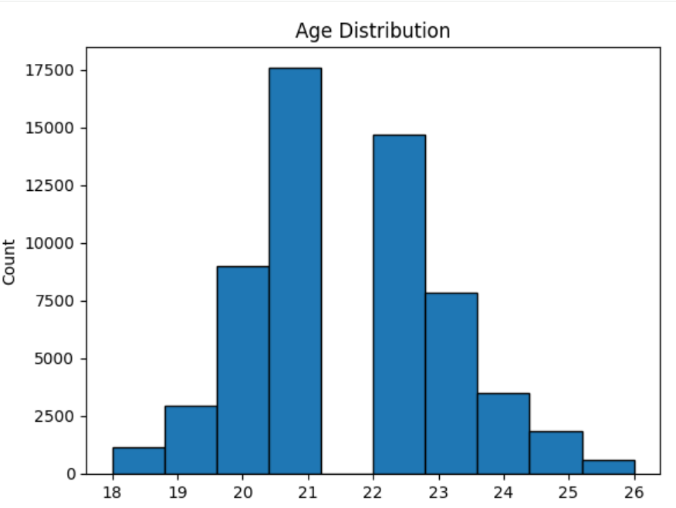

27

2. Plot Name: Boxplot (Salary Distribution)

Working:

- The boxlot displays salary distribution using quartiles (Q1, median, Q3).
- It also shows outliers as points outside the box.

Insights:

- Salary values vary, showing differences in student packages.
- Presence of outliers indicates some students have very high or low salaries.

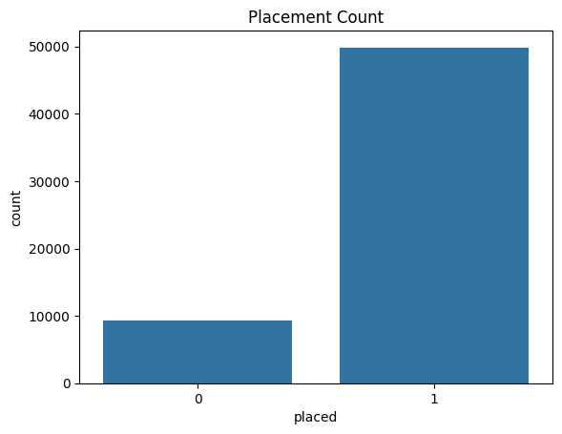

28

3.Plot Name: Count Plot (Placement Status)
Working:
- The count plot counts the number of students for each category (placed = 1, not placed = 0).
- It displays the frequency of placement status using bars.
Insights:
- It shows how many students are placed and not placed.
- Helps in understanding the overall placement rate in the dataset.

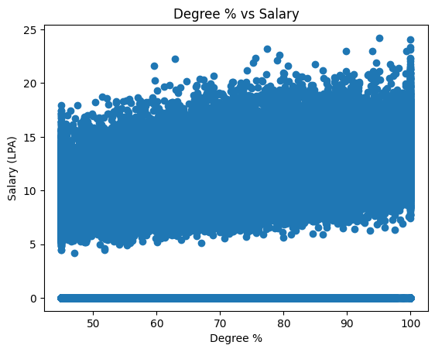

29

4. Plot Name: Count Plot (Gender vs Placement)
Working:
- The count plot shows gender on the x-axis and uses hue='placed' to divide placed and not placed students.
- It displays the count of students for each

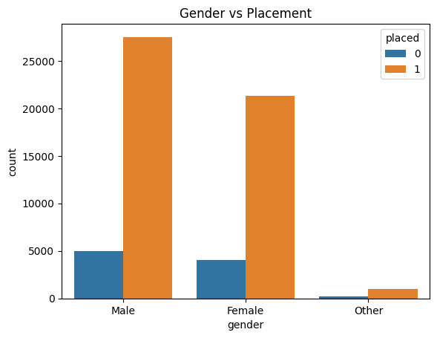

30
5.Plot Name: Scatter Plot (Backlogs vs Salary)
Working:
- The scatter plot shows relationship between backlogs (x-axis) and salary (y-axis).
- Each point represents a student’s backlog count and corresponding salary.
Insights:
1. Students with more backlogs tend to have lower salaries.
2. Indicates a negative relationship between backlogs and salary.
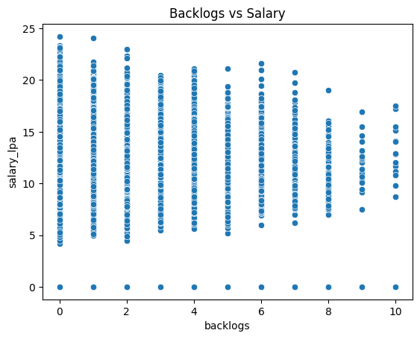

31

6. Plot Name: Boxplot (Technical Skills vs Placement)
Working:
- The boxplot compares technical skills scores for placed (1) and not placed (0) students.
- It shows distribution using quartiles and median for each placement category.
Insights:
- Placed students generally have higher technical skills scores.
- Technical skills have a strong impact on placement chances.

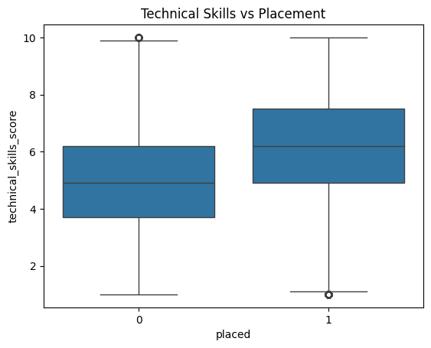

32

7. Plot Name: Heatmap (Correlation Matrix)
Working:
- df.corr() calculates correlation between numerical variables.
- sns.heatmap() displays these relationships using color intensity.
Insights:
- Shows how strongly variables like skills, salary, and backlogs are related.

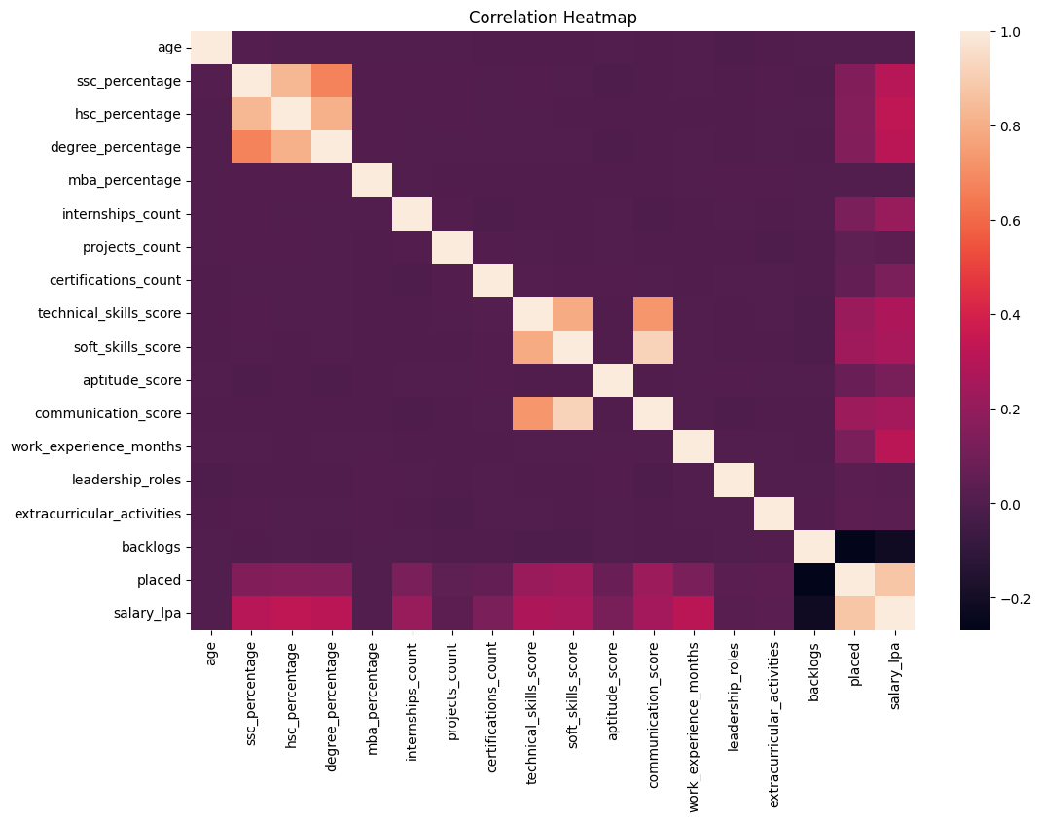

33

8. plot Name: Plot (Skills Scatter vs Salary vs Placement)

Working:
- The scatter plot shows relationship between technical skills (x-axis) and salary (y-axis).
- hue='placed' adds color to differentiate placed and not placed students.

Insights:
- Students with higher technical skills generally receive higher salaries.
- Placed students are mostly concentrated in higher skill and salary range.

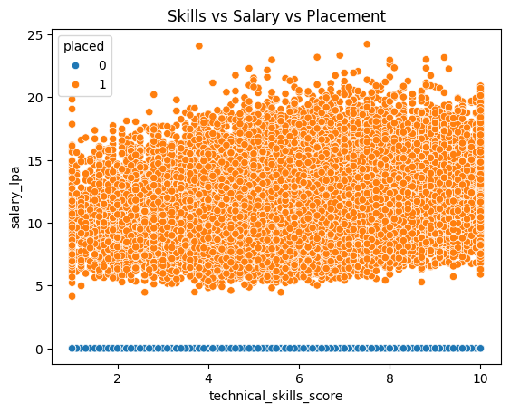

34

9.Plot Name: Boxplots (Outlier Detection)
Working:
- A boxplot is drawn for each numerical column (salary_lpa, technical_skills_score, soft_skills_score, aptitude_score, backlogs) to visualize the data spread.
- It shows median, quartiles, and points outside the whiskers which are potential outliers

Insights:
- Outliers are visible as points outside the box, indicating extreme values in salary, skills, or backlogs.
- Helps in deciding which values need to be removed or treated for accurate analysis.

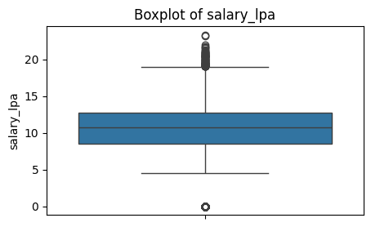
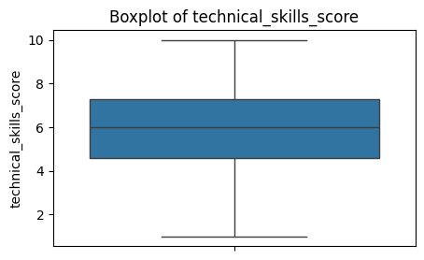
35
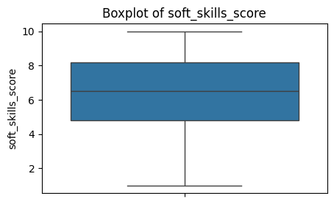

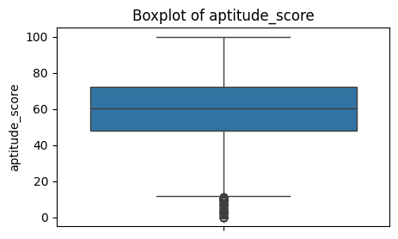

36
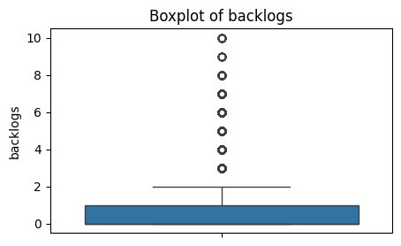

37

#after removal of outliars
10.Plot Name: box plot
Working :
- Uses the IQR (Interquartile Range) method: calculates Q1 (25%) and Q3 (75%), then removes values lying outside Q1 - 1.5*IQR and Q3 + 1.5*IQR.
- Applies this filtering column by column, updating the dataset each time and then visualizes results using boxplots.

Insights :
- Sequential filtering can significantly reduce dataset size, since rows removed in earlier columns are not considered later.
- Boxplots after removal help confirm that extreme values are reduced, making the data more consistent and less skewed.

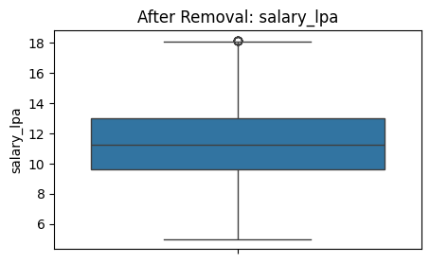

38
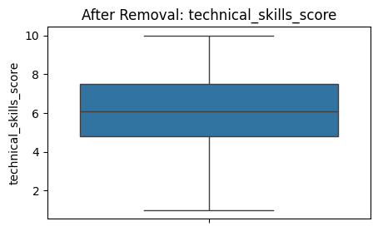

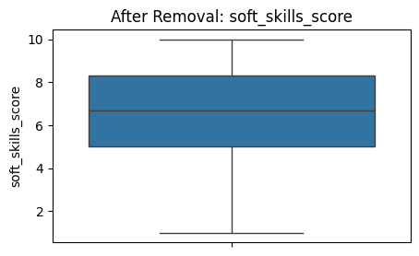

39

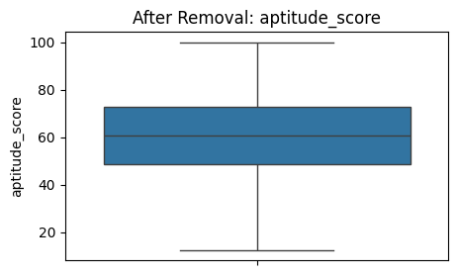

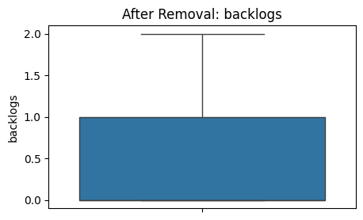

40

CHAPTER 10
Conclusion

10.1 Conclusion
This project focused on performing Exploratory Data Analysis (EDA) on a campus placement dataset to understand the key factors affecting student placement and salary. The dataset used in this project was taken from Kaggle, which provides real-world data for analysis.
The first step of the project involved data collection and loading the dataset into the system using Python. After that, data preprocessing and cleaning were performed to handle missing values and remove duplicate records. This step ensured that the dataset was accurate and ready for analysis.
Various EDA techniques were applied to explore the data. Univariate analysis helped in understanding individual variables such as age, salary, and placement status. Bivariate analysis was used to study relationships between two variables, such as backlogs and salary or gender and placement. Multivariate analysis provided deeper insights by analyzing multiple variables together, such as technical skills, salary, and placement.
Data visualization played an important role in this project. Different types of graphs like histograms, boxplots, scatter plots, and heatmaps were used to represent the data visually. These visualizations made it easier to identify patterns, trends, and relationships in the dataset.
One of the key parts of the project was outlier detection. Outliers are extreme values that can affect the results of analysis. The IQR method was used to identify and remove these outliers, which improved the accuracy of the results.
From the analysis, it was observed that technical skills, aptitude, and academic performance are important factors influencing placement. Students with higher technical skills and better scores have a higher chance of getting placed and receiving better salaries. On the other hand, students with more backlogs tend to have lower placement opportunities.
Overall, the project successfully demonstrated how EDA can be used to analyze real-world data and extract meaningful insights. It also helped in understanding the importance of data cleaning, visualization, and proper analysis techniques.

41

In conclusion, this project provides valuable insights into the placement process and highlights the importance of skills and academic performance in achieving career success.

10.2 Future Enhancements
This project focused on Exploratory Data Analysis (EDA) of a campus placement dataset, but there are many ways in which it can be improved and extended in the future. These enhancements can make the project more advanced, useful, and practical.
One of the major improvements that can be added is the use of machine learning algorithms. In this project, only EDA techniques were used to analyze the data. In the future, models such as Logistic Regression, Decision Trees, or Random Forest can be applied to predict whether a student will be placed or not. This will make the project more powerful and predictive.
Another enhancement is the use of a larger and more detailed dataset. The current dataset is taken from Kaggle, but adding more real-time or updated data can improve the accuracy of analysis. More features like internships, certifications, and project experience can also be included to get deeper insights.
The project can also be improved by creating an interactive dashboard. Tools like Power BI or Tableau can be used to present data in a more dynamic and user-friendly way. This will allow users to explore the data easily and understand the results better.
The project can also be improved by creating an interactive dashboard. Tools like Power BI or Tableau can be used to present data in a more dynamic and user-friendly way. This will allow users to explore the data easily and understand the results better.
Another possible enhancement is automation. The entire process of data cleaning, analysis, and visualization can be automated using scripts. This will save time and make the system more efficient.
The project can also be converted into a web application using technologies like PHP or Python frameworks. Users can upload their data and get analysis results instantly. This will make the project more practical and useful for real-world applications.

42

CHAPTER 11
Refereces
- Wes McKinney, “Python for Data Analysis”, O’Reilly Media, 2nd Edition, 2017.
- Jake VanderPlas, “Python Data Science Handbook”, O’Reilly Media, 2016.
- Aurélien Géron, “Hands-On Machine Learning with Scikit-Learn and TensorFlow”, O’Reilly Media, 2019.
- GeeksforGeeks:https://www.geeksforgeeks.org/
- W3Schools: https://www.w3schools.com/

43

